Login : <http://127.0.0.1:8000/admin/login>

Username : [admin@bukitasam.com](mailto:admin@bukitasam.com)

Password : admin

<http://127.0.0.1:8000/api>

<http://127.0.0.1:8000/api/get-token>

metode : POST

**PARAMETER : secret**

**Key :** 6ce3f47f036365dac4936c1689dfb695

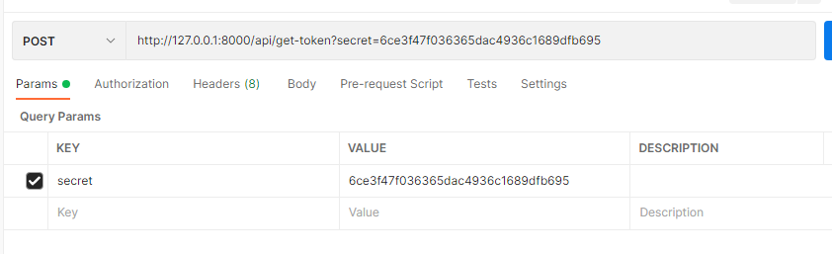

<http://127.0.0.1:8000/api/barang>

Metode : GET

Headers : Authorization Barrer (token)

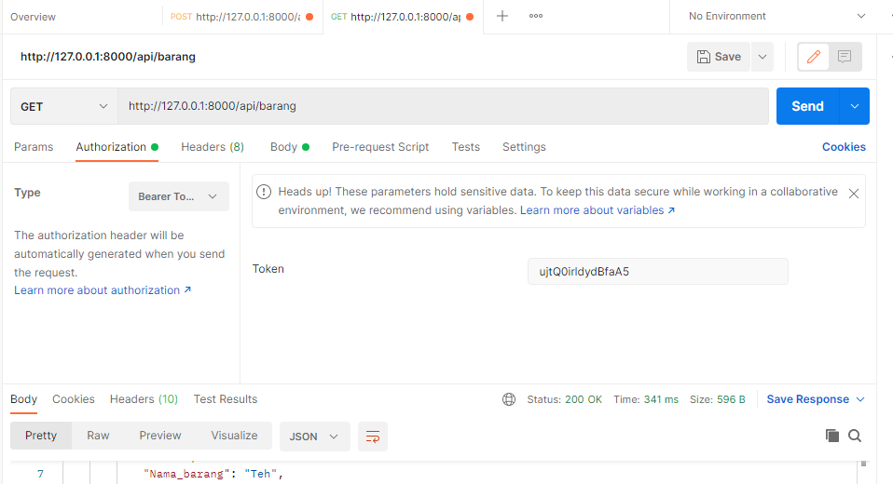

<http://127.0.0.1:8000/api/barangcreate>

Metode : POST

Headers : Authorization Barrer (token)

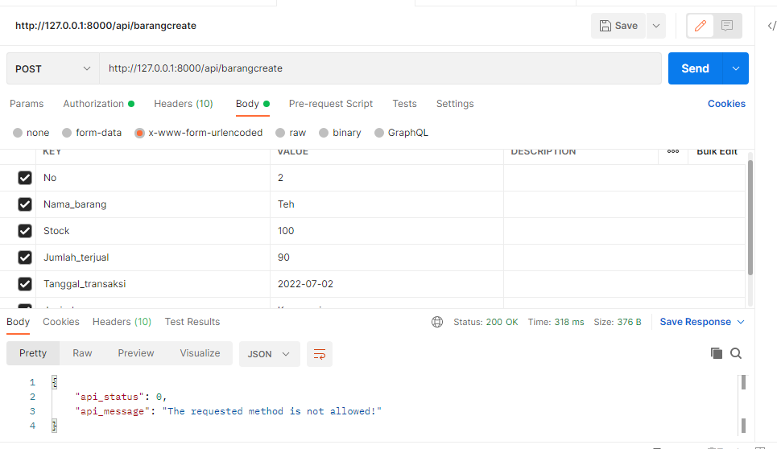

http://127.0.0.1:8000/api/barangdelete

Metode : GET

Headers : Authorization Barrer (token)

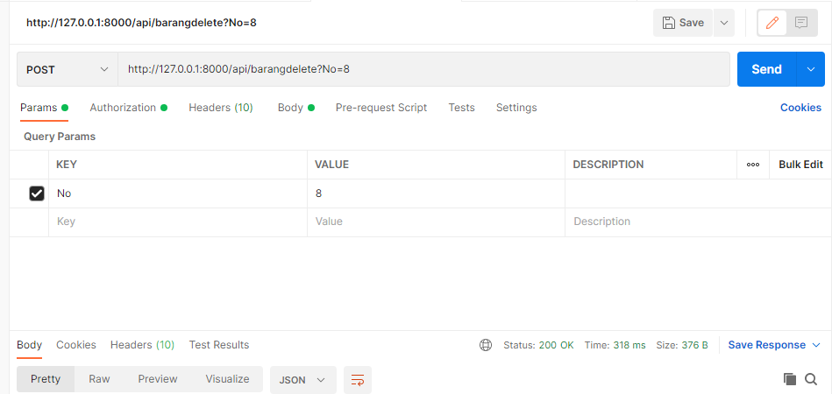

http://127.0.0.1:8000/api/barangread

Metode : GET

Headers : Authorization Barrer (token)

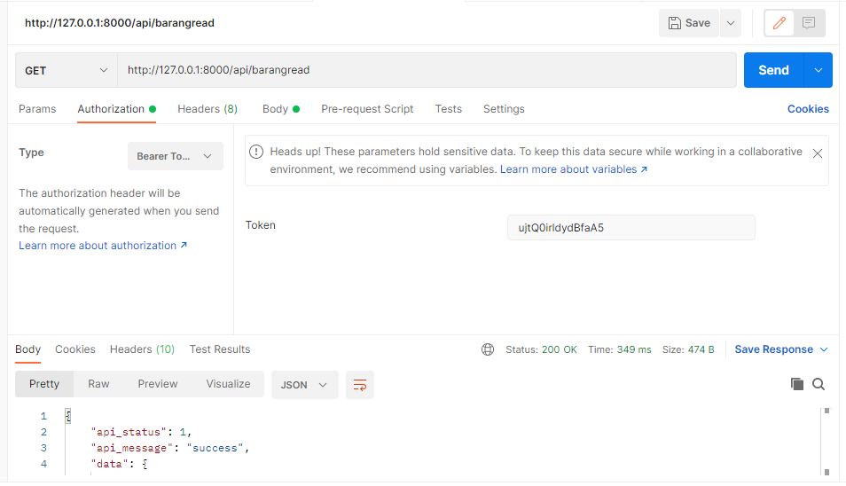

http://127.0.0.1:8000/api/barangupdate

Metode : POST

Headers : Authorization Barrer (token)

